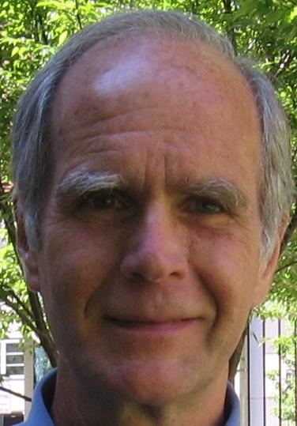
Ted Schettler MD, MPH is Science Director of the Science and Environmental Health Network (www.sehn.org). He also serves as science director of the Collaborative on Health and Environment (www.healthandenvironment.org). He has a medical degree from Case Western Reserve University and a Masters in public health from Harvard University. Schettler has addressed the connections between human health and the food, chemical, built, and social environments in numerous publications and presentations. Recent projects explore the ways in which multi-level interventions can help prevent chronic diseases such as asthma, diabetes, cancer, cognitive decline and dementia. He has served on advisory committees of the US EPA and National Academy of Sciences.

